

NOTRE DAME UNIVERSITY
BANGLADESH
CSE Project Report
Course Title: Object Oriented Programming
Course Code: CSE-1206
Name of the Project: Flappy Bird (A GUI Game)
Date: 25-06-23

Submitted by:
Name: Istiak Alam
ID: 0692230005101005
Batch: CSE-20

Submitted To:
Md. Bayazid Rahman,
Lecturer, NDUB

Project Name: Flappy Bird:
This project is made with java. In this project, I added an interface that will show the GUI game named Flappy Bird. Users can click on the Play button to play the game. Then a new window will open for the Flappy bird game. It is not my first Java Project on games.

JDK Version & IDE:
- JDK 19.0.2 (64bit Version)
- NetBeans IDE 18

Java Libraries:
- Java Swing
- Java Awt
- Java Graphics
- Java Graphics2D
[Note: No external library is used in this project]

Packages:
- flappyBirds
- Pkg2dgamesframework

My Features & Contribution:
- A GUI window will be shown with the Game logo, and users can see the game play button under the Game Title & find the way to play this game.
- This Game is so user friendly that anyone can run the game easily.
- There are some instructions in the ground to play the game.
- This project can be developed further & we can add more features to this game.
- After the game is over, the game will return user to the home page as the user can play this game again without running the whole project.

About The Game:
Flappy Bird is a popular 2D side-scrolling game where the player controls a bird and tries to navigate it through a series of obstacles, consisting of green pipes. The objective is to make the bird fly as far as possible without colliding with any pipes.

In this game, the bird is constantly falling due to gravity, and the player's input is used to control its vertical movement. By tapping the spacebar or the screen, the player can make the bird flap its wings, causing it to ascend temporarily. The challenge lies in timing the flaps correctly to maneuver the bird through the gaps in the pipes.

This game is implemented using the Java programming language. It utilizes graphics libraries like Java Swing to create the game's graphical user interface. The bird, pipes, and background are rendered on the screen, and collision detection is performed to detect if the bird collides with any pipes.

This game keeps track of the player's score, which increases as the bird successfully passes through each pair of pipes. If the bird collides with a pipe or touches the ground, the game is over, and the player can choose to restart and try again.

Overall, Flappy Bird is a challenging and addictive game that tests the player's reflexes and precision. It’s simple yet engaging gameplay mechanics have made it a popular choice among gamers of all ages. I am so proud that at last I created this kind of game project.

Reference and using codes from:
Thạch Phạm Dev,
App Developer,
Vietnam.
tpgamecoding.com - tpgamecoding Resources and Information.

Home Screen Panel:
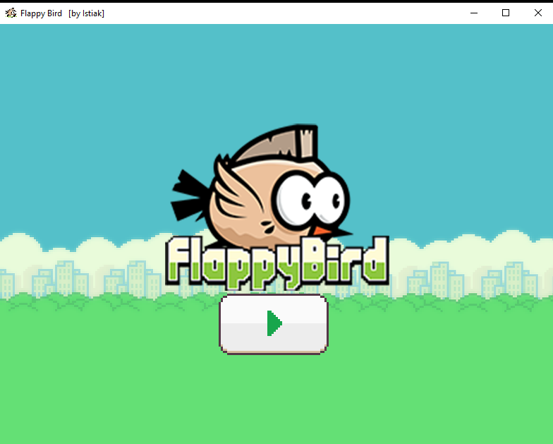

Main Screen Panel:
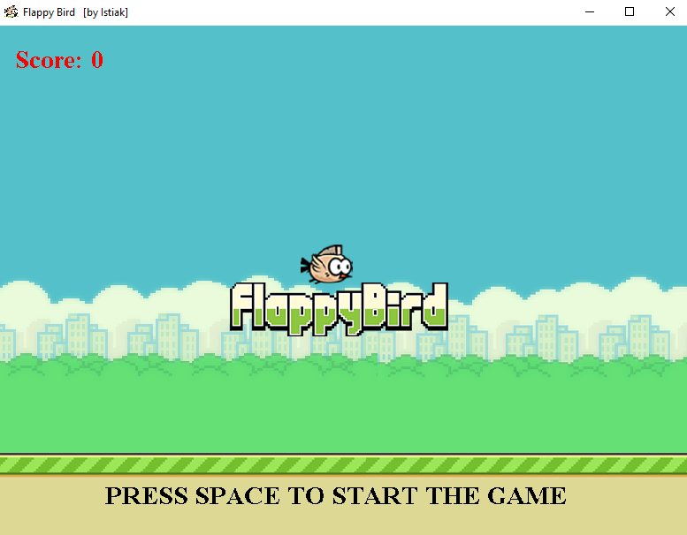
Game Screen Panel:
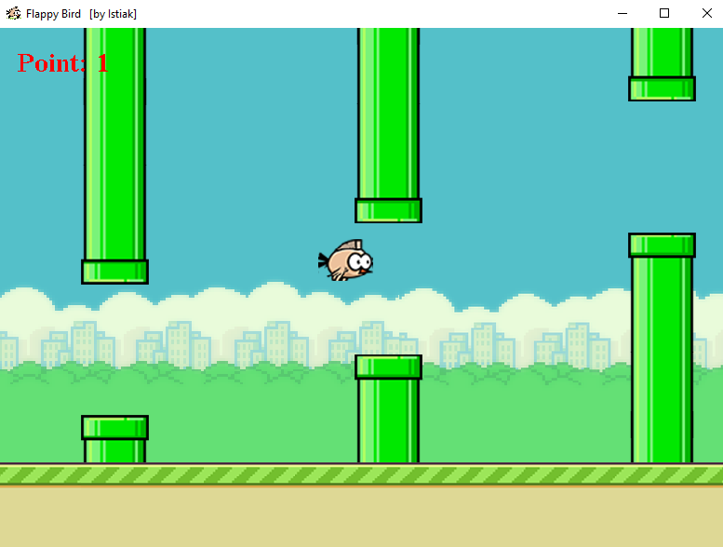

GameOver Screen Panel:
